**STUDENTS PROJECT SCHEME**

**2023-2024**

**ALZHEIMER DISEASE DETECTION SYSTEM**

Submitted by

Poojasree B

Ranjini G

Ganesan N

Sanjai Kanna R



**SNS College of Technology**

Coimbatore

**September 2023**

**TAMILNADU STATE COUNCIL FOR SCIENCE AND TECHNOLOGY**

**STUDENT PROJECT PROPOSAL-2023**

# CERTIFICATE

|  |  |  |  |
| --- | --- | --- | --- |
| **1. Name of the Student (s)**        **one valid e-mail id** | **:**  **:** | **Poojasree B(20IT035)**  **Ranjini G(20IT040)**  **Ganesan N(20IT012)**  **Sanjai Kanna R(20IT042)**  **Poojasrbalaji@gmail.com** | |
| **2. Name of the guide**  **Department / Designation**    **Institution Address**            **Phone no & Mobile No** | **:**  **:**    **:**  **:** | **Ms Parkavi.C,AP/IT**  **Information Technology/ Assistant Professor**  **Department of Information Technology,**  **College of Technology, SNS Kalvi**  **Vazhiyampalayam, Sathy Main**  **Saravanampatti, Coimbatore-641035.**  **9597661751** | **SNS**  **Nagar,**  **Road,** |
| **3. Project Title** | **: ALZHEIMER DISEASE DETECTION SYSTEM** | |  |
| **4. Sector in which your project proposal is to be considered** | **: Engineering and Technology**  **(Computer Science)** | |  |

1. **Project Details : Annexure-I**
2. **Has a similar project been carried**

**out in your college / elsewhere? If so furnish details of the previous : No project and highlights the improvement suggested in the present one**

This is to certify that **Ms. Poojasree B, Ms. Ranjini G, Mr. Ganesan N and Mr. Sanjai Kanna R** is a bonafide final year student of ~~P.G. Science~~ / U.G. Engineering / ~~P.G.~~ ~~professionalcourses~~ of our college and it is also certified that two copies of utilization certificate and final report along with seminar paper will be sent to the Council after completion of the project by the end of April 2024.

**Signature of the Guide Signature of the HOD Signature of the principal/**

**Head of the Institution**

# Annexure-I

**INTRODUCTION:**

Alzheimer’s disease is the leading cause of dementia in older adults. There is currently a lot of interest in applying machine learning to find out metabolic diseases like Alzheimer’s and Diabetes that affect a large population of people around the world. The exact cause of Alzheimer's disease is still not fully understood, but it is believed to be a combination of genetic, environmental, and lifestyle factors. The disease is characterized by the accumulation of abnormal protein deposits, such as beta-amyloid plaques and tau tangles, in the brain. Alzheimer's disease is a complex neurodegenerative disorder that demands thorough research to unravel its mysteries. This document outlines a comprehensive research proposal aimed at enhancing our understanding of Alzheimer's, exploring potential interventions, and contributing to the development of effective treatments.

**OBJECTIVES:**

To Understand the Pathophysiology: Investigate the underlying mechanisms and pathophysiology of Alzheimer's disease to identify key molecular and cellular processes involved in its progression.

TECHNOLOGY/PROGRAMMING LANGUAGE USED

* Python
* Flask
* Artificial Intelligence

## IMPLEMENTATION

Collect data. We need to collect a dataset of brain images and clinical data from patients with Alzheimer's disease and healthy controls. The dataset should be large enough to train the deep learning model effectively.

Preprocess the data. We need to preprocess the brain images to normalize them and make them suitable for the deep learning model. We may also need to perform feature extraction on the clinical data.

Choose a deep learning model. There are many different deep learning models that can be used for image classification. Some popular models include convolutional neural networks (CNNs) and recurrent neural networks (RNNs). We need to choose a model that is appropriate for our dataset and task.

Train the deep learning model. We need to train the deep learning model using our preprocessed data. The training process may take several hours or days, depending on the size and complexity of the model.

Evaluate the deep learning model. Once the model is trained, we need to evaluate its performance on a held-out test set. This will give us an idea of how well the model will generalize to new data.

Deploy the deep learning model. Once we are satisfied with the performance of the model, we can deploy it to production. This means making the model available to users so that they can use it to detect Alzheimer's disease.

**Hardware Specifications**:

* + Windows 10, Ubuntu
  + Ram - 4GB ( minimum)
  + Hard disk - 500GB (minimum)
  + Processor - Intel i3 (minimum)

**Software Specifications:**

* + Python, Flask
  + Images,MRI scans,PET scans.
  + Python and deep learning libraries.

**WORK PLAN**

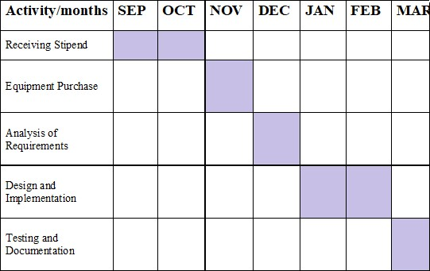

**BUDGET**

|  |  |  |
| --- | --- | --- |
| **S. No** | **Components and**  **Expenditure** | **Cost**  (Rs.) |
| i. | MRI Scan, Hard-disk, RAM | 6000 |
|  | **TOTAL** | **6000** |